MISF Engineering - Capabilities Summary
Engineering | Procurement | Fabrication (EPF Solutions)

About MISF Engineering
MISF Engineering, LLC is a Texas-based multidisciplinary engineering firm providing fit‑for‑purpose Engineering, Procurement, and Fabrication (EPF) solutions.
Our team brings 80+ years of EPC experience across facilities equipment — but not limited to pressure vessels, heat exchangers, rotating equipment, brownfield modifications, and modular systems.
Licensed Professional Engineers in multiple U.S. states, MISF delivers compliant, practical, and manufacturable solutions for Oil & Gas, Petrochemical, and Renewable Energy sectors.

Core Services
- Multidisciplinary Engineering/Design – P&IDs, datasheets, and process simulations
- Static Equipment Engineering/Design – Pressure vessels, heat exchangers, air‑cooled exchangers, packages
- Rotating Equipment Engineering/Design – Pump and compressor
- Fabrication & Vendor Support – QA/QC, FAT witness, and procurement
- Modular Package Design – Compressor skids, refurbished units, tie‑in engineering
- Owner’s Engineering – Technical reviews, TBEs, and vendor bid evaluations
- Fit-for-purpose Assessment – Per API 579/ASME FFS-1, Engineering Analysis (FEA)

Key Capabilities & Software
HTRI, PV Elite, Compress, AFT Fathom, Aspen EDR
3D Modeling – SolidWorks, Revit integration
Vendor network – US, Canada, Gulf Coast fabrication yards
SMEs in all engineering disciplines

Typical Deliverables (but not limited to)
- Process Simulation, PFD, P&IDs, PSV sizing, Datasheets, Cause and Effect, HAZOP/HAZID
- Code Calculations, FEA, Stress Analysis report, Major Equipment list, line list, Valve list, Specialty Items List, Piping and Valve Materials Specification
- Request for Quotes (RFQs), Technical Bid Evaluations (TBEs), Request for Purchase (RFP)
- Single line Diagram, ETAP, Electrical Load List, Electrical Cable schedule
- Instrumentation Index, Instrument Datasheets, Instrument Cable Schedule
- Structural Analysis, weight summary
- Fabrication support and FAT documentation

SAMPLE/EXAMPLE PROJECTS DRAWINGS/CALCS SHOWN

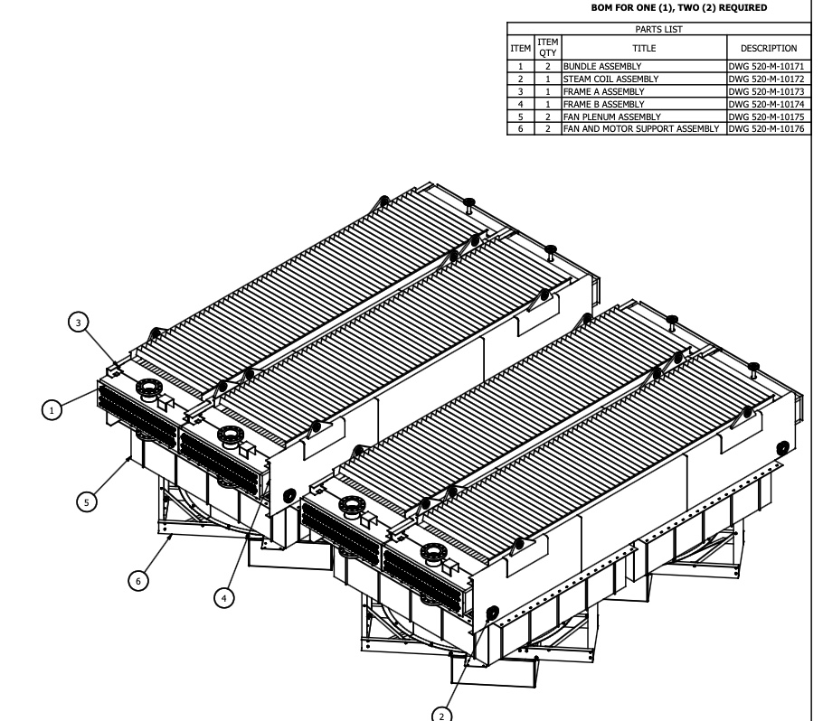
AIR COOLED HEAT EXCHANGER DETAILED DESIGN/DRAWINGS

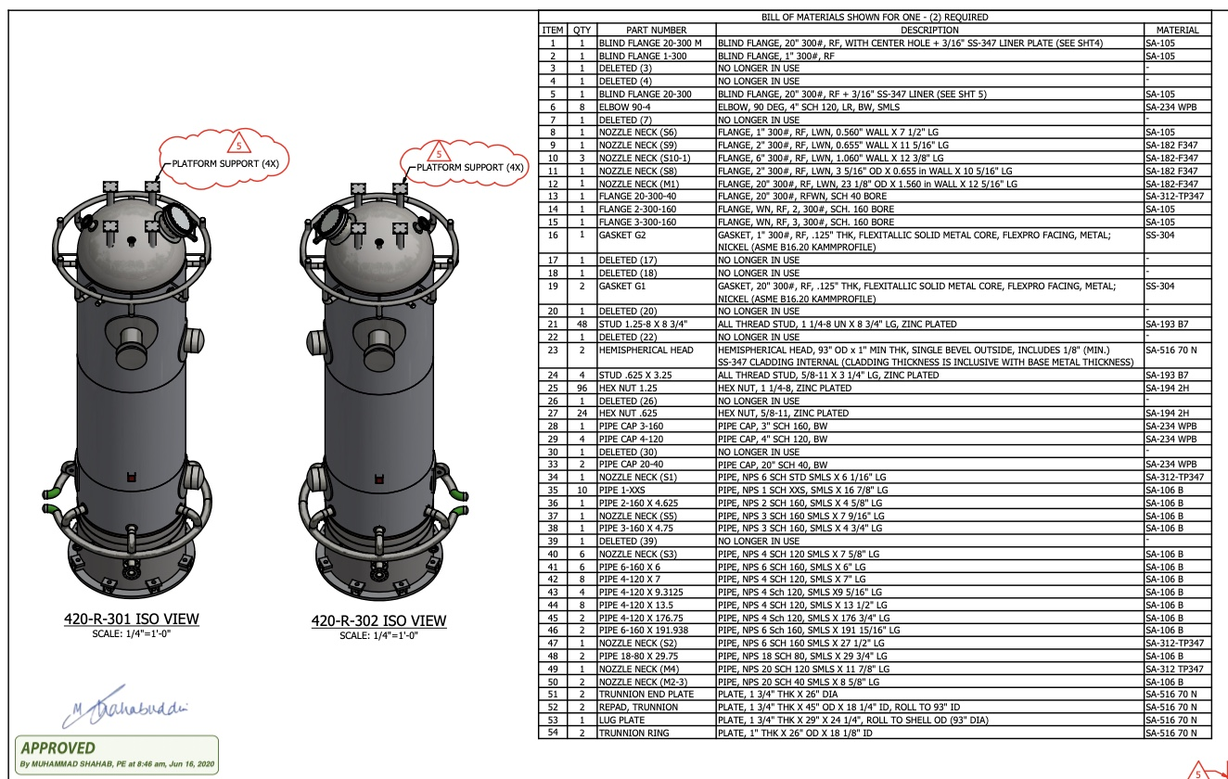
EFT REACTOR DETAILED DESIGN/DRAWINGS

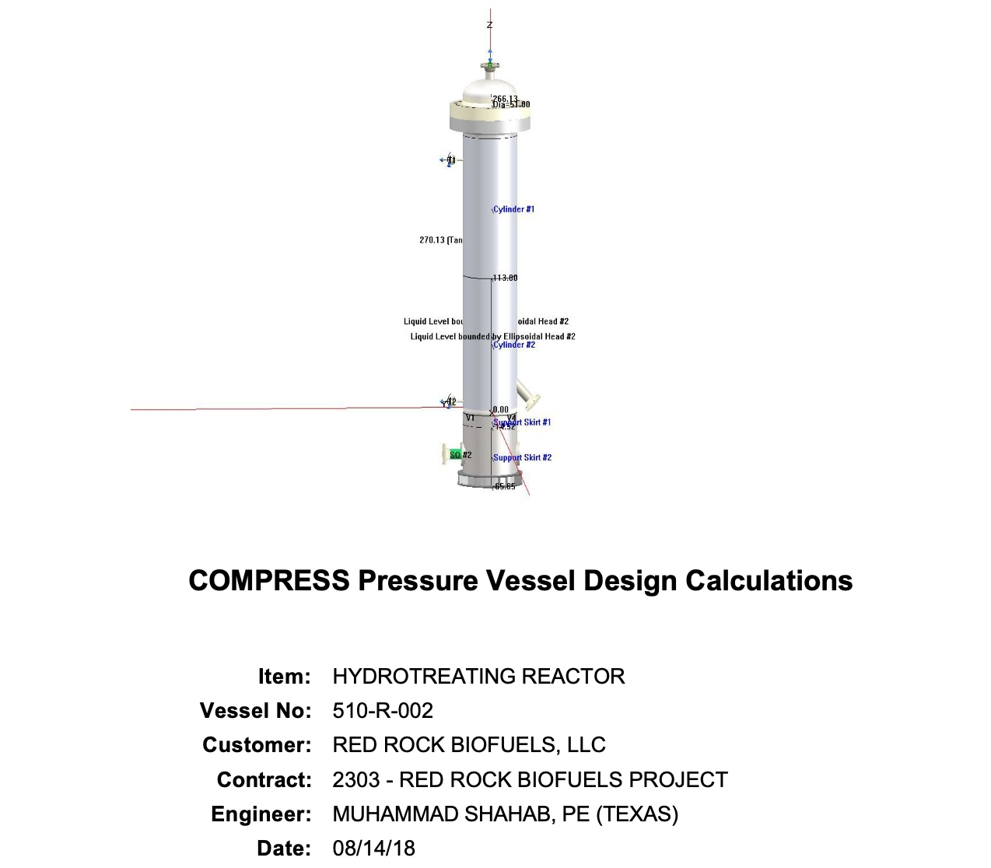
HYDROTREATER REACTOR ASME BPVC VIII CODE CALCULATIONS

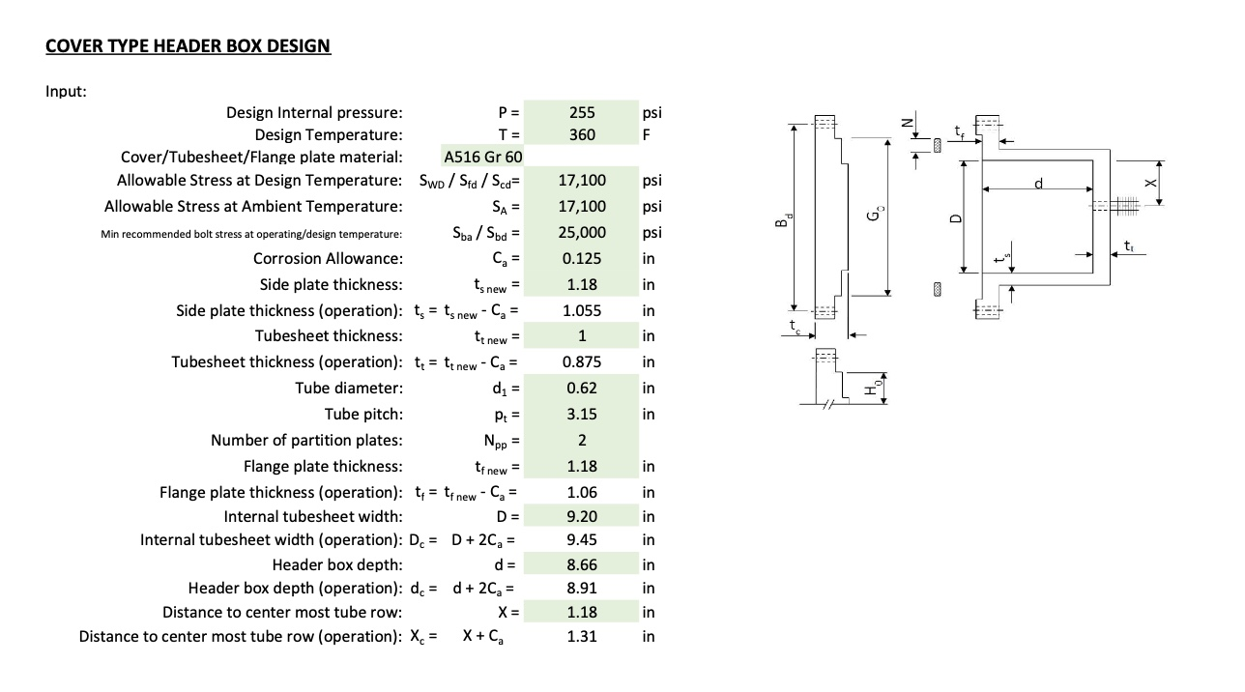
REMOVEABLE COVER TYPE HEADER BOX CODE CALCULATIONS

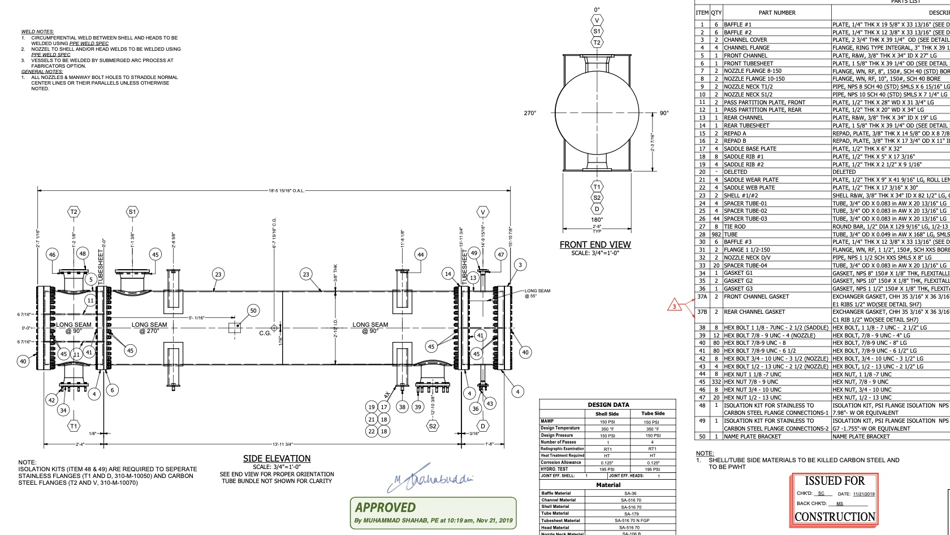

SHELL AND TUBE HEAT EXCHANGER DETAILED DRAWING

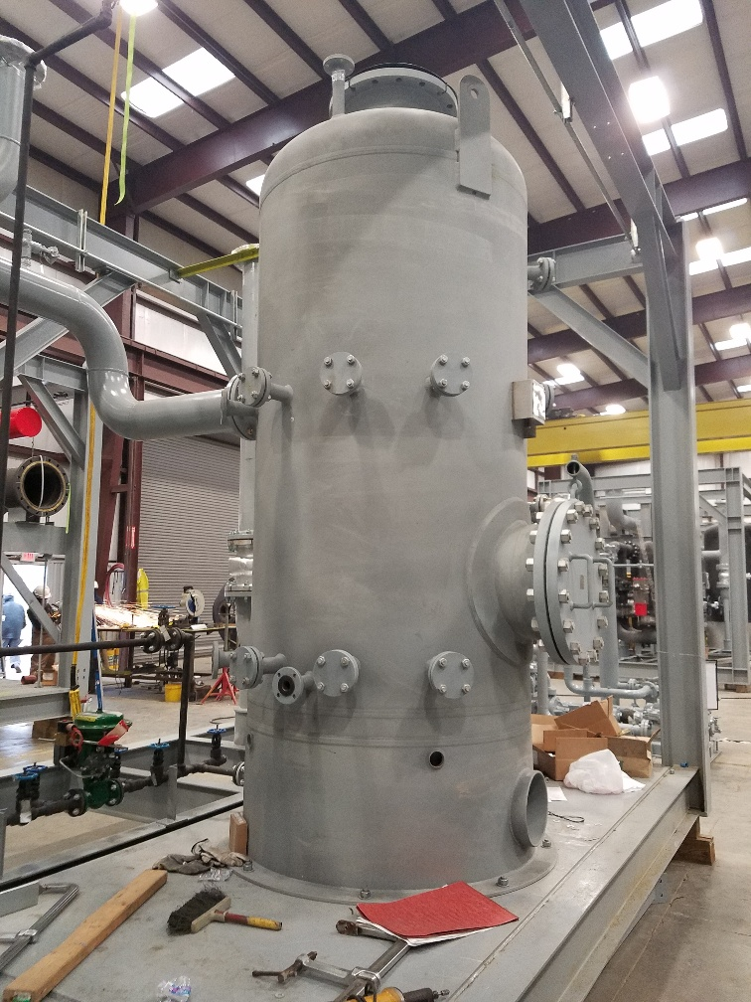
PRESSURE VESSEL BUILT IN-HOUSE AND DESIGNED BY THE MISF TEAM
MISF STANDARD DELIVERABLES LIST (COMPLETE LIST NOT SHOWN)

Contact & Next Steps
📞 +1 (281) 962‑8518
✉️ info@misfengineering.com
🌐 MISFEngineering.com
Partner with MISF Engineering for comprehensive EPF solutions — from concept to fabrication.

